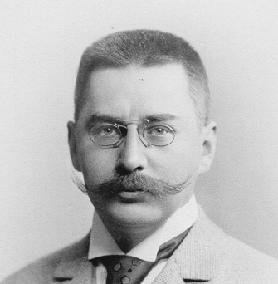  Guidelines for new employees  School of Business and Economics  Ladislaus von Bortkiewicz Chair of Statistics | Name abbreviation:
Contact: Tel: +49 [30] 2093-5630 | Fax: +49 [30] 2093-5649 | stat@wiwi.hu-berlin.de | http://lvb.wiwi.hu-berlin.de

OFFICIAL (BUSINESS) TRIPS
- An application form is to be submitted 4 weeks in advance
- The application will only be authorised if employee is an active participant of an event (for example, presenting a paper at a conference)
- A maximum two official trips per year will be authorised
- The costs involved should be clarified in advance
- Application forms and reimbursement forms available from secretariat (LU and AZ)
- Application for reimbursement is to be made within four weeks after returning from trip

CARD KEY FOR THE FACULTY ENTRANCE
- Available from and authorisation required from Frau Wöß (phone -5674) in advance

KEYS FOR LvB
- LvB: available from the secretariat (LU)

PHONE LIST OF EMPLOYEES
- Available from the secretariat (LU)

ANNUAL LEAVE
- The number of days granted depends on the age of the employee
- Applications are to be made at least 14 days in advance of the leave
- Annual leave for employees with teaching duties will not be granted during semester time
- Annual leave record cards are kept in the secretariat

LvB COFFEE MACHINE
- Mandatory membership fee to the Coffee Club of €25.00 is to be paid to the secretariat (LU) within two weeks of start of work
- The kitchen cleaning duty roster is posted weekly on the secretariat door

CMS ACCOUNT
- Apply via the HU intranet for an account (RV)

LEQR Account
- Apply online (https://leqr.wiwi.hu-berlin.de/leqr/) and use the HU email

OFFICE HOURS

GUEST LIST
- A list of the current guests is available online (https://www.wiwi.hu-berlin.de/de/forschung/irtg/guests)

STATIONERY
- Available from the secretariat (LU)

PRIVATE INTERNAL POSTBOX (LvB library, Room 401)
- Refer to the secretariat (LU)

PRIVATISSIMUM
- Date and place: information available from the Moodle internet site

INSTITUTE MEETINGS (DIENSTBESPRECHUNG)
- Date of scheduled meetings: information available from the secretariat (LU)

PRIVATE PHONE NUMBER AND ADDRESS

PRIVATE PHONE CALLS USING HU LINES
- A PIN should be requested from Frau Wöß via email (woess@wiwi.hu-berlin.de);
the email to her should contain your room number and the official phone number
- Bills are regularly prepared by the HU

OFFICE HOURS AT HUMAN RESOURCE DEPARTMENT (Personalabteilung)
Tuesdays, 09.00-12.00 hrs
Wednesdays, 13.00-15.00 hrs
Fridays, 09.00-12.00 hrs
Location: Main building (UL6, ground floor)

CODE FOR PC POOL
- Code: 017930

EMPLOYEE ABBREVIATION
- Personal abbreviation (WH)

EMPLOYEE INTRODUCTION
- You are required to familiarise yourself with other LvB employees and their tasks (one per day from the start of your employment)

PHOTO
- To be provided for the website

NATIONAL FLAG
- To be displayed on or near your desk. Available from Flaggenhaus am Alex, Propststr. 1, 10178 Berlin

HOMEPAGE
- Your detailed personal homepage should be on the LvB website within a month of the start of your employment (www.wiwi.hu-berlin.de/professuren/quantitativ/statistik/members)

I agree to the terms and conditions.

_____________________________
Date, Signature

